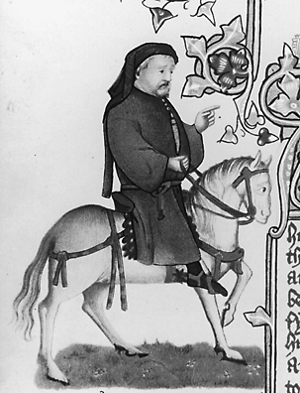
Chaucer Web Quest

- Approximately between what years did Chaucer live?

- What was his official job?

- List three interesting facts about Chaucer’s life.

- What is Chaucernet? How do you join? Why would you join?

5.

