Ms. Mork
Emma
Project

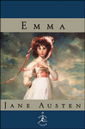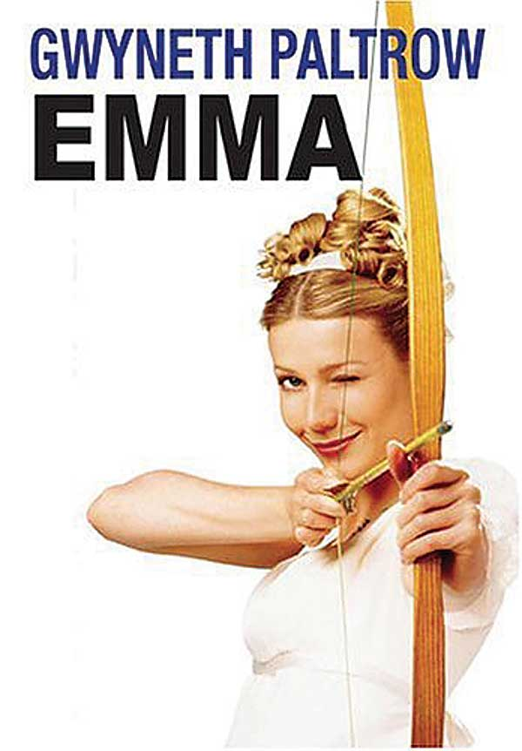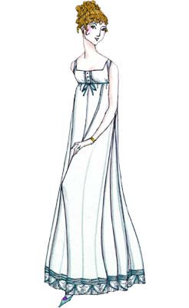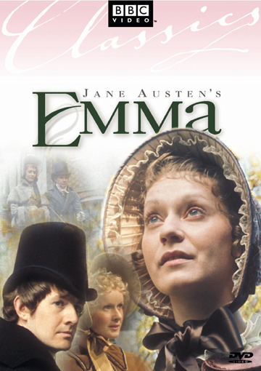

An in and out of class project of choices: Emma

For this final project, you are going to have your choice of levels of work. Your final project should have a cover page with your name and desired level, and a table of contents of the options that you chose. Each piece within your bound packet should be labeled with the assignment description from this prompt as well as the chapters we had read at that point (i.e. “Shorter Length - Video Game” – Chapters 1-26). Your work should be detailed, neat, thorough, interesting, and creative!

In Class Working Days: 6
Homework at Night: 4

A Level Work – to attempt an A on this project, you must complete six of the shorter length (daily) options, and two of the longer analytical options. If you choose this level, you may work on two of the shorter options with a partner, provided you each turn in a copy of the work in your final packet, labeled with your partner’s name.

B Level Work – to attempt a B on this project, you must complete four of the shorter length (daily) options, and two of the longer analytical options. If you choose this level, you may work on one of the shorter options with a partner, provided you each turn in a copy of the work in your final packet, labeled with your partner’s name.

C Level Work – to attempt a C on this project, you must complete three of the shorter length (daily) options, and one of the longer analytical options.

images’ source: “Emma.” http://www.googleimages.com 1/30/07.
Shorter Length (Daily) Options: these options are meant to be completed in NEAT handwriting single spaced on loose leaf paper during class. At the top of the page, label the assignment, and write the date and the chapters we have read at that point. Your work for the day is meant to show your understanding of the reading up to that point, with the understanding that it may not be the whole picture.

1. Write a one page reflection on the role of class in what you have read so far and the role of class in today’s U.S. Society. Include at least one quotation from the book.

2. List 10 character traits and the characters you see them in – provide a quotation for each as evidence and then briefly discuss whether or not you admire the trait in the character and why

3. Write a gossip column for Emma’s neighborhood newspaper of about one page, describing social doings using evidence from the text you’ve read so far and also making insinuations and guesses at what is to come

4. Write the script of a one and a half page conversation between yourself and Emma relating to the issues and themes of the book so far, either in her life or yours, or both. Be careful to use the details Austen has given us about Emma so far to inform Emma’s
dialogue.

5. Write a one and a half page script of a discussion between several people about last night’s reading, including a minimum of three questions, two textual references, and two disagreements.

6. Cite a passage from last night’s reading (write it out) and then bullet a minimum of five points about it in a close reading (ex: discuss tone, characterization, symbolism, important events, literary devices, historical context, etc.)

7. Write a point / counterpoint of ½ page each first arguing that Austen is a wonderful writer and giving examples of why everyone should like her, then arguing the opposite

8. Create a video game for Emma’s world. Who will the character(s) be? What will each level entail? What will be the goal? Describe in at least 1 ½ pages.

9. Imagine Emma was in charge of theme week. Describe the overall theme and each day in the week, giving a quotation for each day you choose to back up your choice.

10. Choose a character and a college you think they would apply to. Briefly explain why you think they would apply to that college and then write a one page response in your character’s first person voice to the application essay question: What will you bring to our community?

11. Illustrate and write a three page graphic novel short involving characters from the novel as portrayed by Austen, but in a new situation you invent.

12. Choose a character and make a list of what you think his/her top five favorite websites would be in he/she was alive today. This should require some research, don’t just rely on the websites you already know, unless the character is just like you. List the URL and then explain the lure of the website for your chosen character. (Approximately one page.)

13. Write a one page letter or greeting card (may include illustration on the front that serves a purpose) from one character to another, showing your understanding of their relationship and recent events in the novel.

14. Make a list of a character’s top ten favorite movies, giving a quotation to support each choice and briefly describing why he/she would so enjoy each film.

15. Write a (minimum) one and a half page story about some aspect of Webb life, mimicking or parodying Jane Austen’s style.

16. Interview three other teachers or administrators on Jane Austen – have they read her? Which books? In what context? What did they think? Have they seen movies of her works? Etc. and then briefly describe the interviews in about ½ page each.

17. Adapt some event from the novel into a three page screenplay

18. With a partner (doesn’t count as one of your optional partner pieces): each create a list of five discussion questions from last night’s reading and then interview each other, writing up the other’s responses. Go every other question, and as the interviewer, draw out your partner and ask for evidence. Write up your questions and your partner’s responses – labeling the paper with the interviewee’s name at the top. This does not need to count as one of your two partner exercises, as each of your final product’s will be different.

18. Invent your own – think of a way of interpreting the book that suits you and run it by me for approval…

Analytical (After Reading) Options: these options are meant to be TYPED up and completed once you have finished reading Emma, though you may be able to begin them by hand along the way in class.

1. Invent an arguable thesis for this novel and outline it with three main points and two supporting quotations for each.

2. Write a two page character analysis with a minimum of three main points and one supporting quotation for each.

3. Research Jane Austen’s life and works using at least one print source and a max of one internet source and write an interesting two page bio. Cite your sources fully.

4. Read or watch The Jane Austen Book Club and write a one page book / movie review, dealing especially with the section on Emma.

5. Create three thought-provoking in-class essay topics in 4-5 sentences each. Craft a thesis in response to each topic.

6. Give a worthwhile ten minute lecture / presentation on some aspect of the novel or its historical context, or on Jane Austen (let Ms. Mork know when you are ready to do this, and we can fit you in on an in-c project work day).

