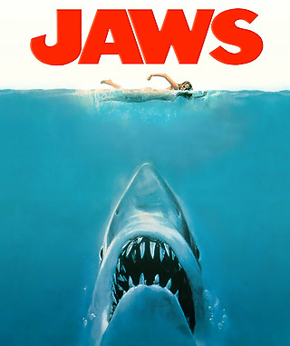
Name: Class:

A study in character development and all sorts of other cool literary devices!
List 5 ways a character can be developed.

-

-

-

-

-

#1) As you watch this movie, pay attention to the development of the 3 major characters. I have given you a description of each, give details and examples from the movie that help to develop these characters.


BRODY
- A quiet and brooding man with a strong set of morals – a sense of right and wrong.
- A man who is haunted by his own fears, and by his own conscience.
- Under the surface, he is more loving and caring than he might appear.
- *He is definitely the “outsider” – in both the town, and with his 2 shipmates.

details & examples from the movie about Brody

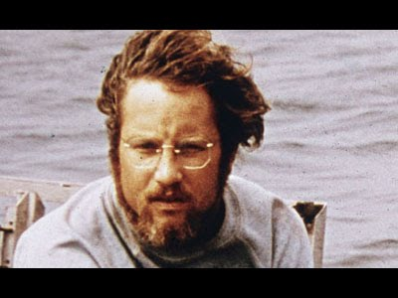
MATT HOOPER

- A conscientious and dedicated scientist. Some might call him a little obsessive when it comes to sharks.
- He comes from a family with a lot of money. But is he spoiled?
- He is keenly interested in technology.
- He has more in common with Quint than he does with Brody.

details & examples from the movie about Matt

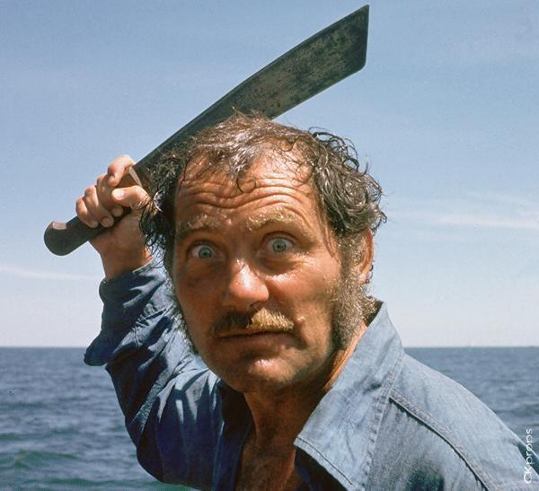
QUINT

- A man with many demons that haunt him.
- He is also a bit of an outsider in the town.
- He is very much a loner, preferring his own company to that of others.
- He has been referred to as a little “nutty.”
- Has a sense of humor – but often at other people’s expense.

details & examples from the movie about Quint

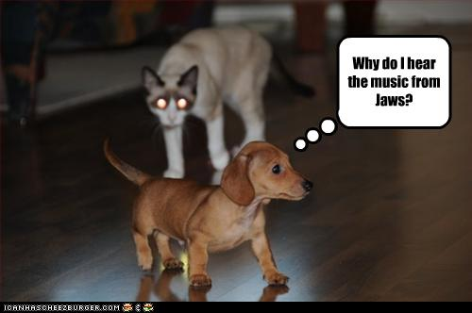
#2) Use of foreshadowing.
There are many examples of foreshadowing in this movie. List as many as you see. Some are ‘visual”, but not all!

#3) Symbolism.
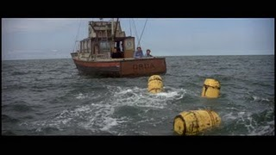
- what do the yellow barrels symbolize? *hint, they symbolize different things at different times….

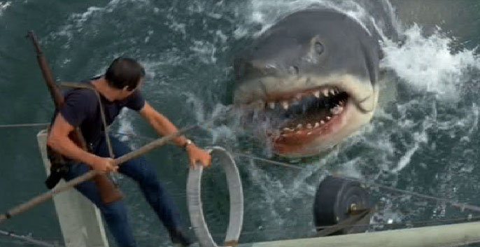

- what does the shark symbolize for Quint?

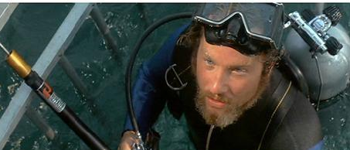

- What does Hooper’s “lack of spit” near the end of the movie symbolize?

#4) The movie creates different moods at different times. Remember that “mood” applies to the emotion that YOU feel, not those of the characters.

- What is the mood created when the girl is swimming?

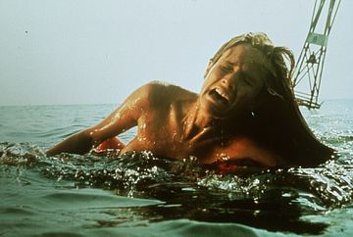
- How is this mood created?


- There are two different moods (almost like they are layered) during the scene where Brody’s family is relaxing on the beach. Explain each mood and how each is created.




#5) There are a couple of flat stereotypical characters in this story. One of them is Mayor Vaughn. What kind of stereotype is he – support this with details from the movie.

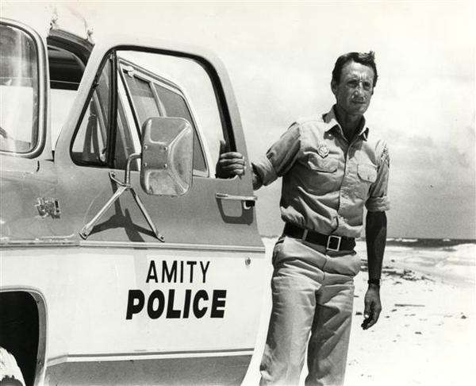
#6) There is a very obvious form of “irony” in the movie – it has to do with the reasons that Brody moved his family to Amity in the first place.
Explain.

#7) There are two MAIN “physical” settings in this movie. Describe each – and try to explain how each of the settings is very important to the “Mood” of the story.

1-
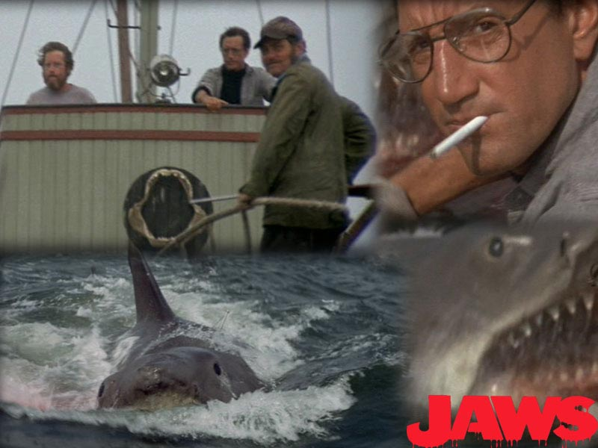
Important to mood:

2-

Important to mood:

#8) Why is the time of year or season (also a part of setting) important in this story?
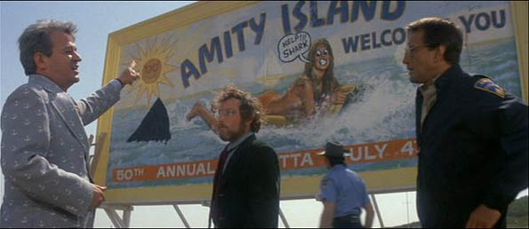

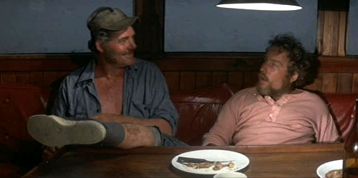
#9) There is one major “flashback” that occurs.
- Briefly describe it.

- How does this flashback contribute to the character development of Quint, and what makes this flashback so important to the plot

#9) Give 2 possible “themes” in this movie. Express each theme in one sentence.

Theme 1:

Theme 2:

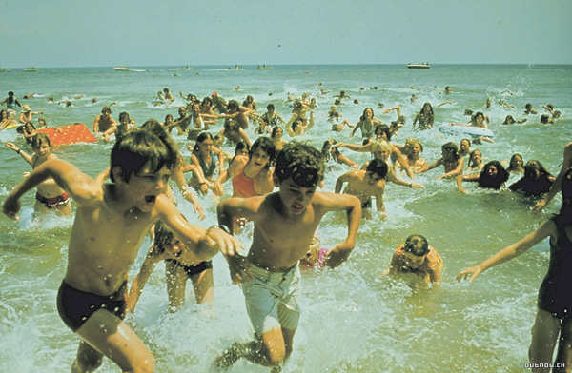
#10) In which “genre” would you most likely categorize this movie? Why?

•Action • Adventure • Animation (American anime, computer animation) • Avant-garde • Biographical • Children • Comedy • Crime • Disaster • Documentary • Drama • Economics • Epic • Exploitation • Fantasy • Heist • Horror • Independent short • Mockumentary • Musical • Mystery • Religious • Romance • Science fiction • Snuff • Sports • Superhero • Thriller • War • Western (Spaghetti Western)

11. Answer 1 of the following questions in at least 3 paragraphs.

- Once the mayor convinces 1 family to get in the water, everyone feels safe to get in. What message does this end about group logic? What are of some other examples when this happens?

- When there is believed to be a shark in the water everyone rushes out trampling others, only concerned for their own safety. What message does this send about fear? What are of some other examples when this happens?

- Should the mayor be considered a villain? Why or why not?

