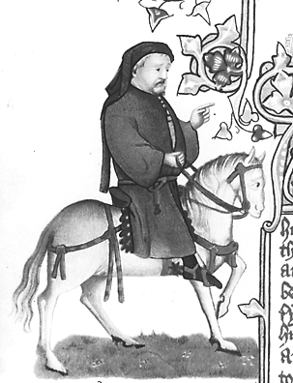
Here bigynneth the presentation of the pilgrim’s pages

Congratulations! The Host of this pilgrimage to Canterbury has invited you and your friends to act as pages for one of the pilgrims. As you work together, you will get to know your pilgrim so well that you will burst with desire to share your newfound experience with your fellow students. As well-educated and literate pages, you will prepare a written and oral presentation fulfilling the following requirements:

Booklet (40 points)
Includes in the following order, bound in a folder or by some other creative means:
- Title Page – This should be creative and include the name of your pilgrim [5 points]
- Page 1 -- Name of pages and what actions each performed in service of the pilgrim and the presentation [3 points]
- Page 2 -- Description of the pilgrim and characterization (go in depth; you have spent time with this person, after all!) [10 points]
- Page 3 – Summary of the pilgrim’s tale; paragraph(s) on what the tale reveals about the pilgrim [10 points]
- Page 4 – Artistic rendering of the pilgrim (no clipart/internet art) [7 points]
- Page 5 -- Works Cited page (no internet sources) [5 points]

Visual Aid (20 points)
This can be a video, a skit, or poster, which teaches the student more about your pilgrim. Be creative! Let the Mistress of the Pages know ahead of time what equipment you will need. The school does not have facilities for Illuminated PowerPoints. The Mistress of the Pages will award points for creativity and effort. No slackers!

Presentation (15 points)
Your presentation should take between 15 to 25 minutes (no longer!), including the visual aid. Make sure everyone participates!

Important Reminder to Potential Pages:
In order for pages to effectively serve their pilgrim and report back their experience, they must share the burden equally. Indeed, if one page chooses to play with a bow and arrow all day, all that pilgrim’s other pages will suffer. The Mistress of the Pages will evaluate your performance as a group, not as individuals.

Due Dates

Patron Pilgrim | Due Date
The Wife of Bath | 11/15
The Merchant | 11/20
The Franklin | 11/21
The Pardoner | 11/26
The Prioress | 11/28
The Nun’s Priest | 12/4

